Pokhara University

Level: Bachelor | Semester – Fall | Year : 2011
Programme: BE |  | Full Marks: 100
Course: Electronics Devices |  | Pass Marks: 45
 |  | Time : 3hrs.

Candidates are required to give their answers in their own words as far as practicable.
The figures in the margin indicate full marks.

Attempt all the questions.

 |  | - Given I_{D}=1mA, Is=10×10⁻¹¹A, η=1.6. Find r_{D} and V_{d}. Also find V_{f}. All the symbols have an usual meaning. Consider room temperature.  - Determine whether Zenor diode is ON or OFF. Also determine whether diode is operating safely. V_{Z} = 10V, P_{ZM} = 80mW.  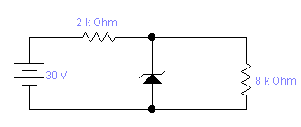 | 7  8
 |  | - Explain the input and output characteristics of a BJT transistor in CE configuration.  - Define and distinguish transition and diffusion capacitance of a diode. What is their significance in the circuits where diode is used as switching element? | 7  8
 |  | - With neat sketch and its significance explain BJT switching time in detail.  - For the following transistor amplifier configuration, draw small signal r_{e} equivalent model. Calculate input impedance, output impedance, and voltage gain using small signal r_{e} model neglecting the effect of r_{o}. Given; β = 100, V_{cc} = 12V, R_{B} = 5K and R_{E} = 2K  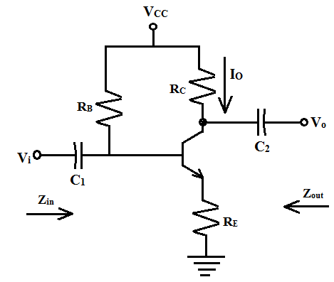 | 8  7
 |  | - How many types of biasing are done on a BJT to work properly as an amplifier? Which one is the best and why?  - For the transistor shown below, find the operating point.  R₁=10K  R_{C}= 1K  V_{cc} = 15V  R_{E}  =2K  V_{in}  I₀  R_{L}=1K  R₂ =5K  - Draw the high frequency T-model for a transistor in CE configuration. Define it’s various parameters. | 5  5  5
 |  | - Explain the drain characteristics of a JFET with necessary diagram.  - In an N-channel JFET, the input voltage, V_{GS} is applied at -2.5 Volts. JFET parameters are given as I_{DSS} = 12 mA and V_{P} = -4.5 Volts. Determine the value of transconductance.  - Distinguish between JFET and MOSFET? | 5  5  5
 | - Determine the output of network in the figure and plot it for sine wave input of V_{m}= 60V with period Pi (π).  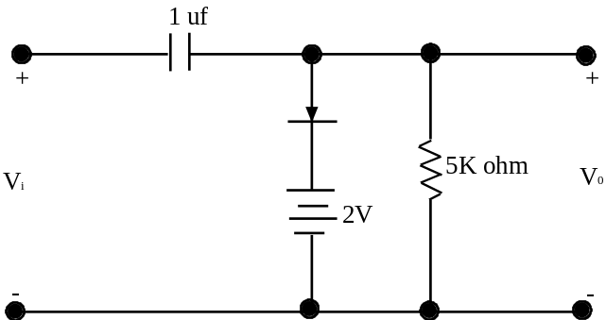  - For a circuit shown in figure sketch V₀ and determine the required PIV rating of each diode.  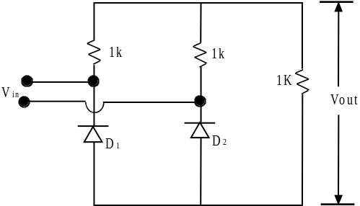  5  0  V  2  π  π  -  5  0  V  w  t  V  i  n |  |  | 7  8
 |  | Write short notes on any two:  - Piecewise liner modeling  - Eber- Moll Model  - JFET merits and demerits | 2×5

